# **VBCS Screen – SO-Creation**

This VBCS screen is referred to create new Staffing Order and record the job requisition and Staffing Accountant can process the order successfully.

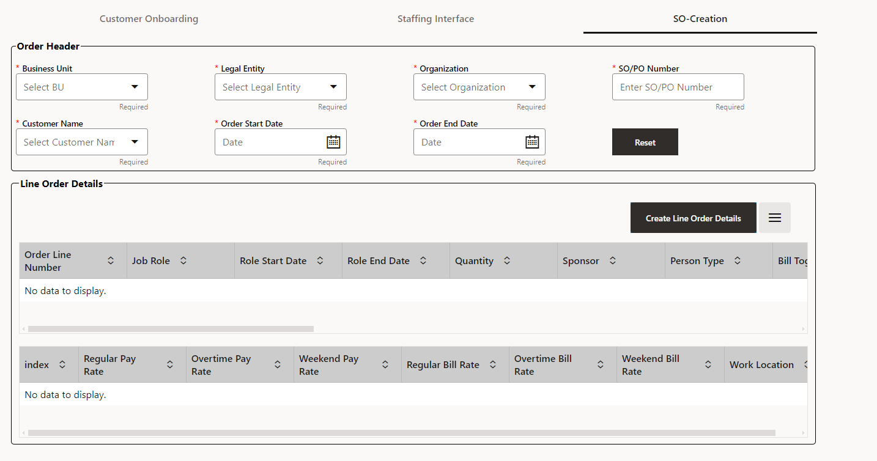

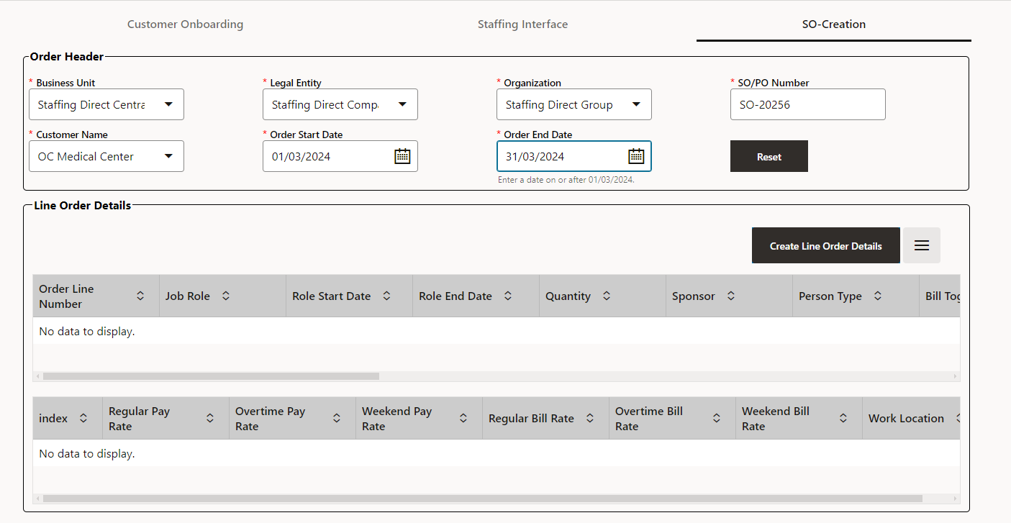

* Fill all the mandatory details of Order Header and then click on Create Line Order Details.
* Every staffing job requisition will have a default quantity of 1.
* Every staffing job requisition will have ATT1 (JOB REQ Number) populated SO-<REQ NUMBER>-<LINE NUMBER>
* Every staffing job requisition will have ATT2 (Placement Status) populated as “Open.”

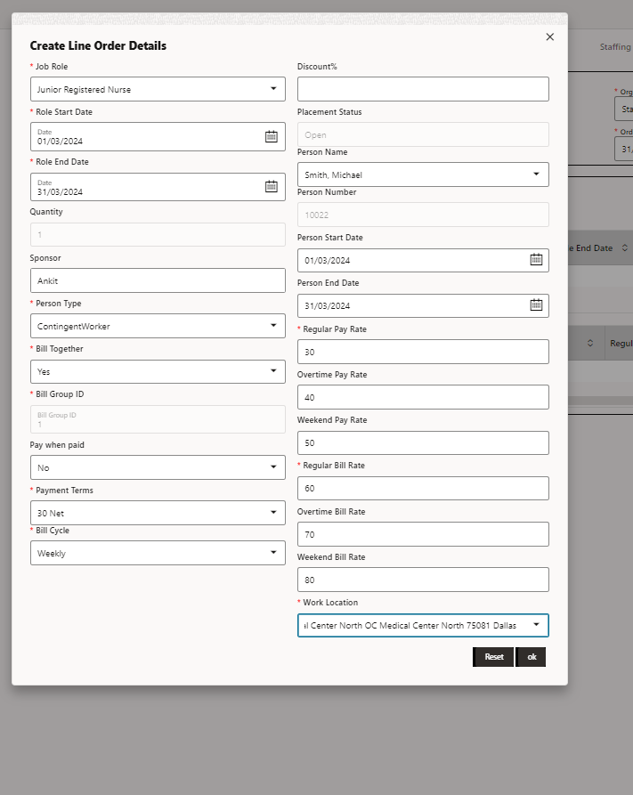

* In order to generate a new line order, the user must complete all the required fields and then click on **OK** button.
* Person type determines the name of the person, and the name of the customer determines the work location.
* User can virtually create n number of job requisitions against each order.

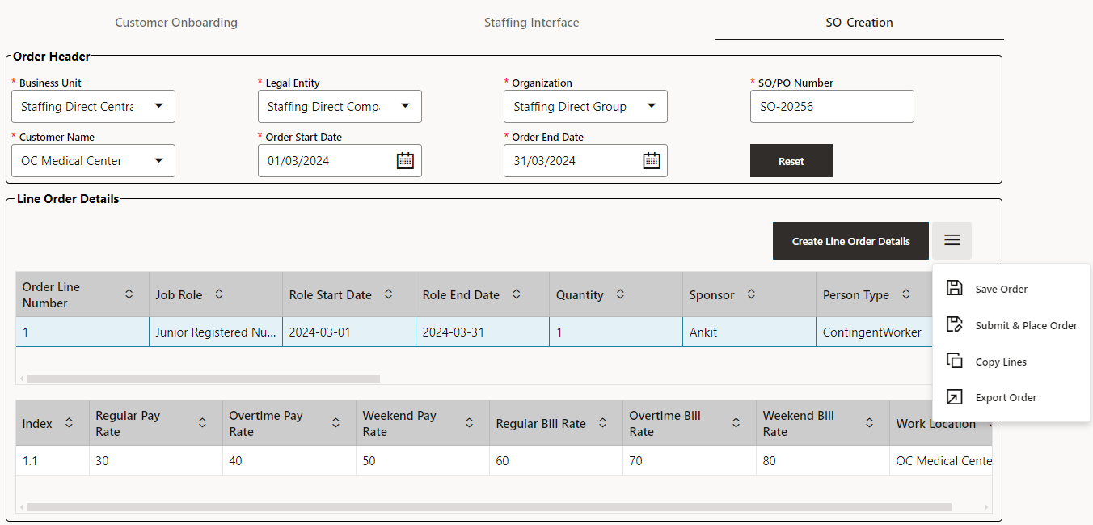

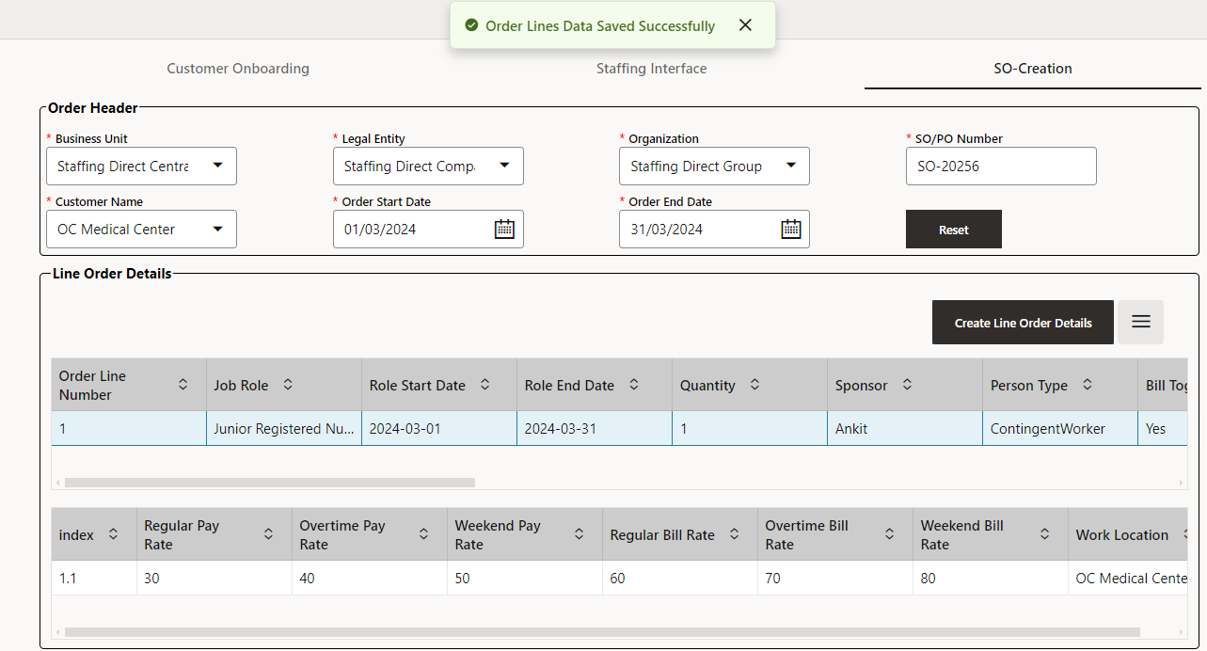

* Orders are saved in ATP table when you click on **Save Order,** and you will receive a notification stating that the order lines data was successfully saved.
* After, the order has been saved, you can click on the **Submit and Place** to submit and place the order.
* If there is no person present then you receive the notification **Project- created successfully , Contract -created successfully** and if person is present then you receive the notification **Project- Placement successful**.

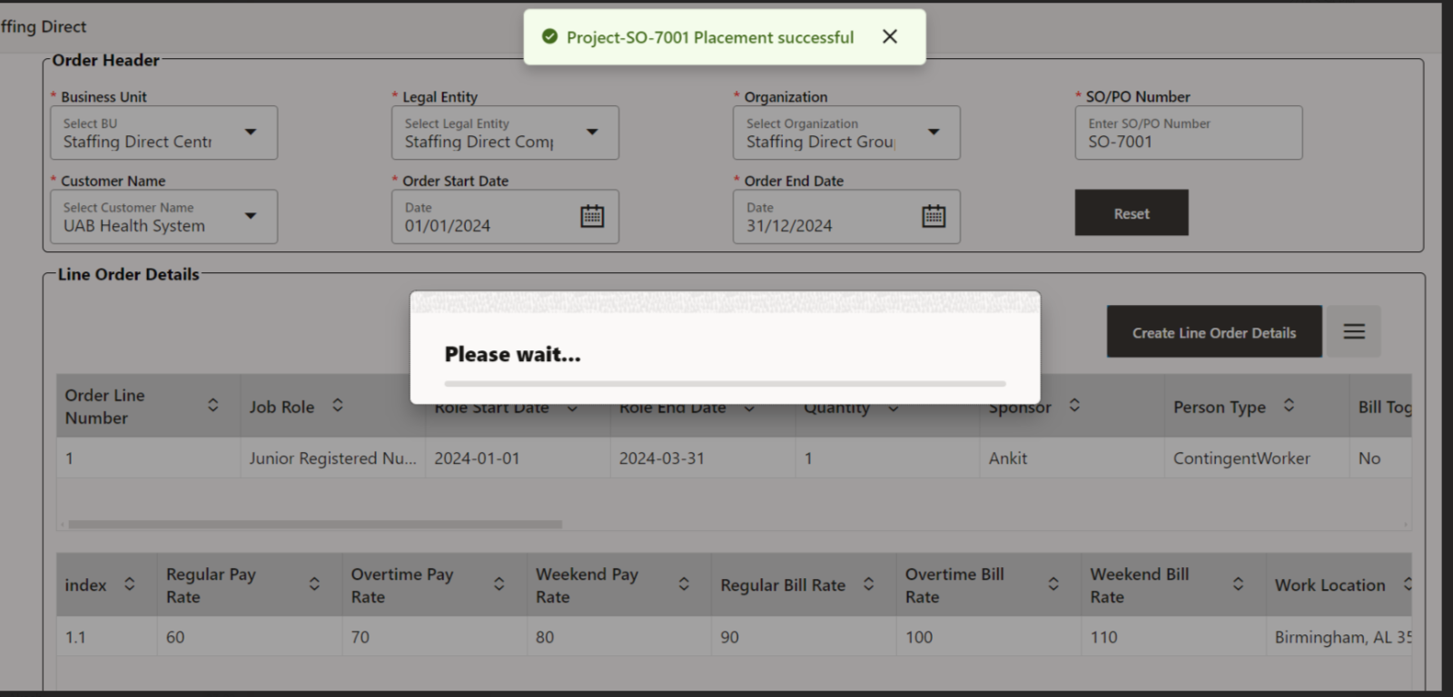

* Staffing accountants can copy the job requestion using **Copy Lines**.
* To obtain the data in an Excel document, click **Export Order**.